RochesterBassMasters Couples Tournament

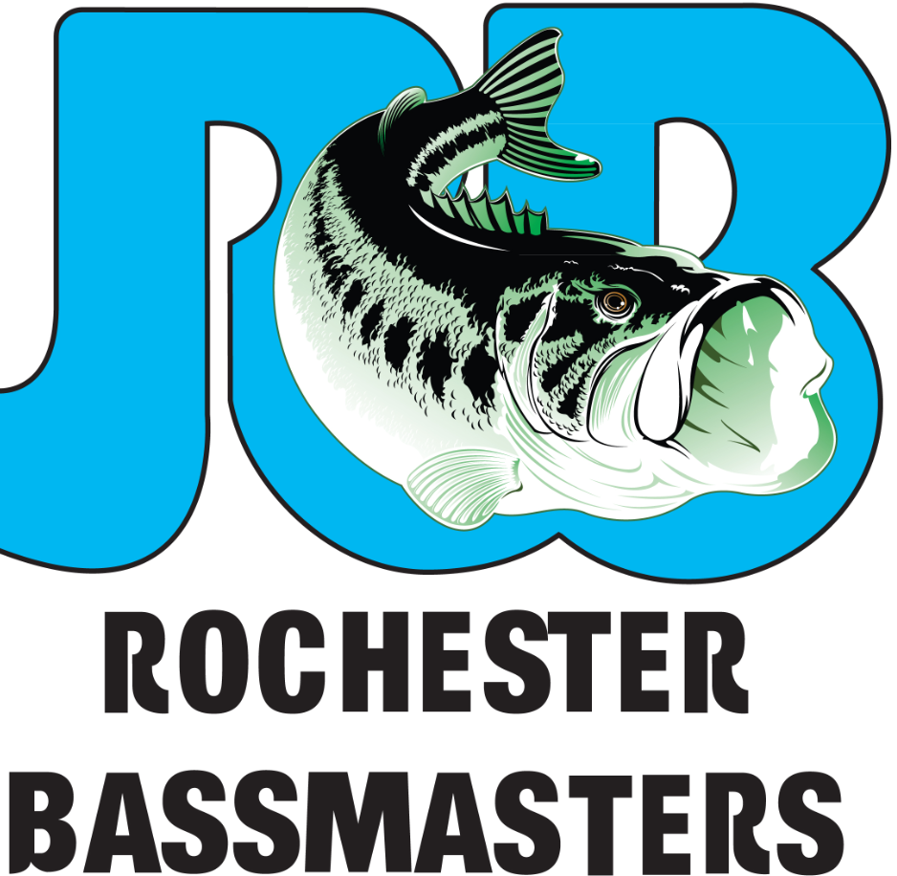
Sunday July 29th
7:00AM to 12:00 tournament
Launch at 9555 Ridge Rd, North Rose, NY 14516 (South End of Sodus, bay bridge sport shop, Launch fee $6 per boat)
12:30 to 1:30 is lunch with prizes (at Dockers)
Cost is $30/couple
Includes:
      - Lunch (bread, soup, salads, vegetable, pasta, chicken)
      - 1st Place trophy
      - Payout 1st $150.00, 2nd $100, 3rd $50.00, plus additional prizes.
Tournament Rules:
- Leave Baybridge at 7:00am. If you plan on fishing but starting later than 7:00 please call Tom (585-298-1687)or Fred (585-217-6298) just to let us know.
- 5 fish limit, 1 of which has to be caught by member’s teammate. If both participants are members each has to contribute at least one fish to the 5 fish limit.
- Prizes for heaviest 5 fish limit, lunker, lady lunker and smallest keeper bass(smallmouth or largemouth). If weighing a bass for smallest keeper bass you may bring a 6th fish to scale.
- No live bait.
- Be at Dockers by 12:00 noon.
- Tournament directors may limit fishing waters (bay only?) depending on weather.
Please confirm with Tom Haley (585-298-1687) or Fred Ratcliffe (585-217-6298) by July 19th if you will be attending as a final count is needed.

